W
LAWHENZ
E N E R G Y
POWERING HOMES, BUSINESSES & INSTITUTIONS WITH RELIABLE SOLAR ENERGY
COMPANY PORTFOLIO
2026
08135839293 • info@lawhenzenergy.com • www.lawhenzenergy.com

01 ABOUT LAWHENZ ENERGY

Who We Are
Lawhenz Energy Ltd is a renewable energy and power solutions company providing reliable, scalable and sustainable energy solutions for homes, businesses, institutions and commercial facilities.
We design, supply, install and maintain solar energy systems that help our clients achieve reliable electricity, lower energy costs and greater energy independence.
Every solution we deliver is built around the client's actual energy needs, load profile, budget and future expansion plans — because no two homes or businesses consume power the same way.

Reliable  Power | Scalable  Systems | Sustainable  Energy

02 OUR SERVICES

What We Do
We offer a full range of solar and hybrid energy services, tailored to each client's site and power needs.

Residential Solar Solutions
Solar and battery systems designed for homes, estates and high-energy residential properties.
Commercial & Industrial Solar
Large-scale solar solutions for businesses, factories, offices, institutions and commercial facilities.
Solar EPC
Complete Engineering, Procurement and Construction services — from energy assessment and system design through procurement, installation, testing and commissioning.
Battery Energy Storage
Advanced battery storage solutions for backup power, energy management and improved energy independence.
Hybrid Energy Systems
Integration of Solar, Battery, Grid and Generator to provide a more reliable and efficient power solution.
Energy Audit & Consultation
Professional assessment of a client's electricity consumption, power sources and energy costs to determine the right energy solution.
Operations & Maintenance
System monitoring, preventive maintenance, troubleshooting and after-sales technical support to keep solar installations performing efficiently.

03 OUR PROJECTS

Proven Delivery, Across Sectors
Our project portfolio demonstrates our experience delivering solar and hybrid energy solutions for a wide range of clients — from private homes to industrial facilities.
Project Categories
- Residential — Solar Installations for private homes and estates.
- Commercial — Energy solutions for offices, retail and commercial facilities.
- Industrial — Large-scale power solutions for factories and industrial sites.
- Institutional — Deployments for schools, institutions and organisations.
- Solar + Battery — Combined solar and battery storage installations.
- Hybrid Power — Integration of solar, battery, grid and generator power.

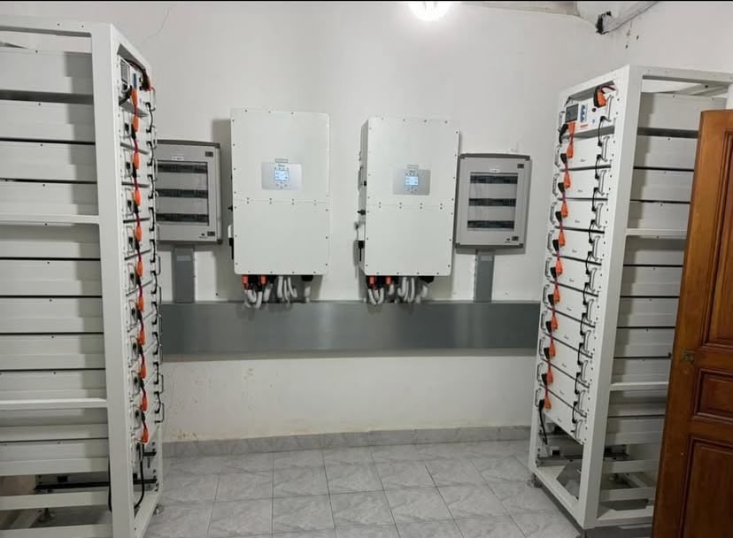
Battery Bank & Inverter Room — Industrial / Institutional Installation

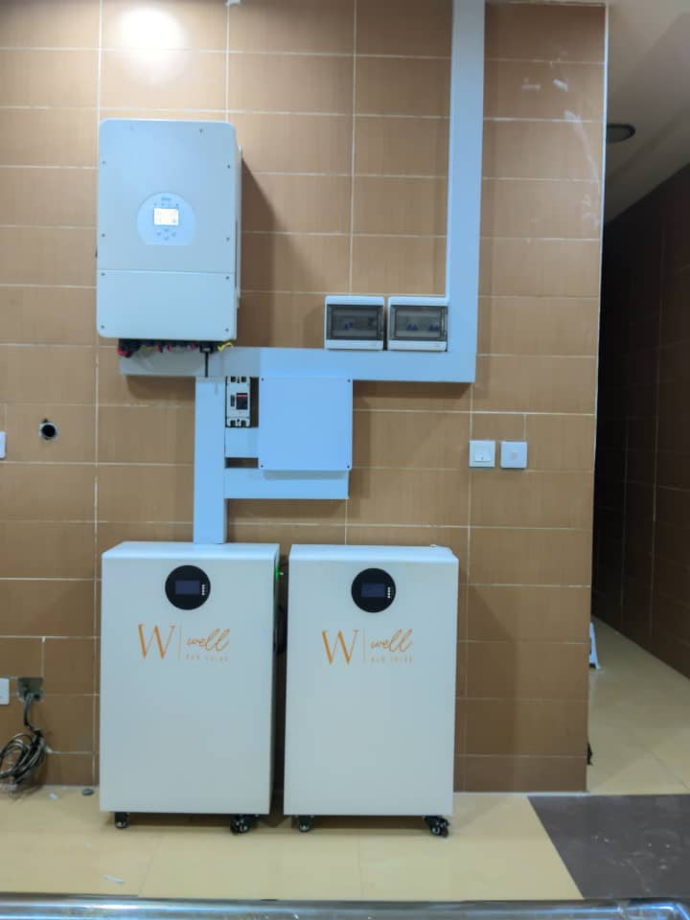
Residential Hybrid Inverter & Storage — Solar + Battery System

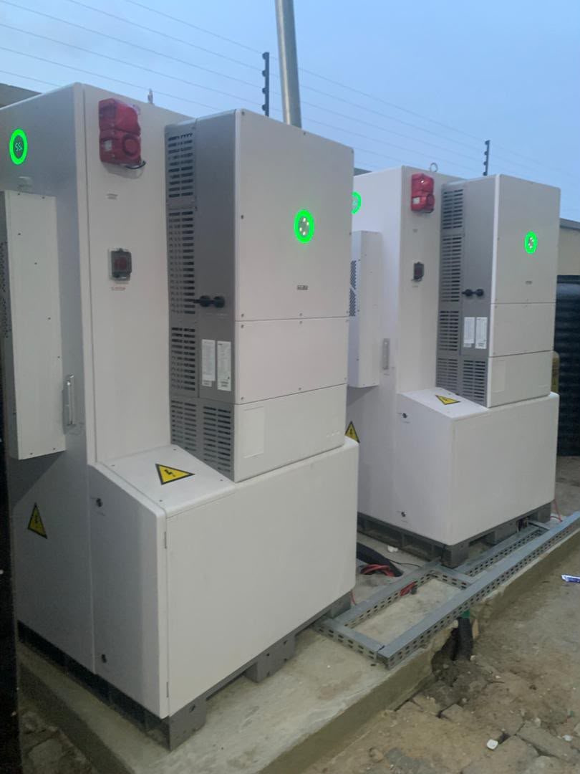
Outdoor Industrial Power Cabinets — Industrial Energy Solution

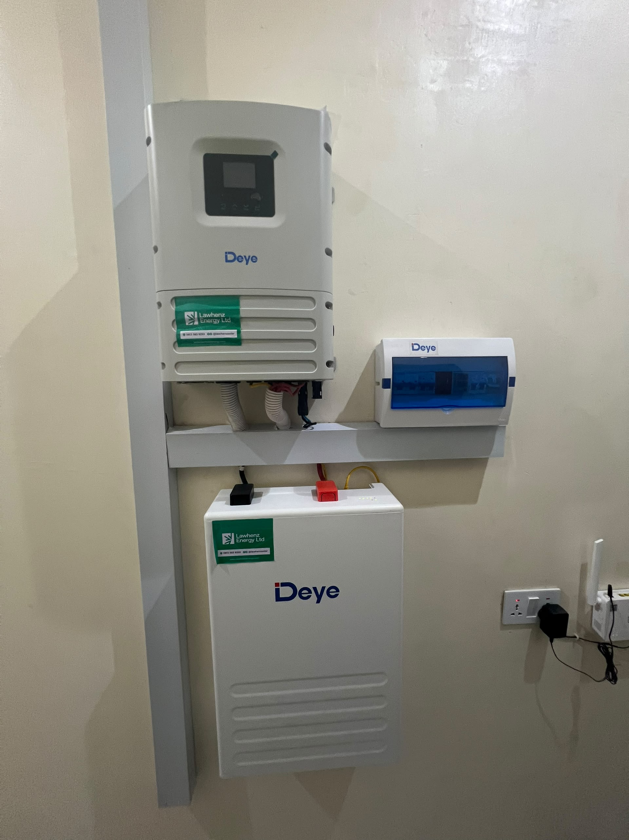
Deye Hybrid Inverter & Battery Install — Residential Solar Installation

04 LEADERSHIP

Meet Our Managing Director

Udenna Lawrence C.
MANAGING DIRECTOR, LAWHENZ ENERGY LTD
Under the leadership of our Managing Director, Lawhenz Energy has built a reputation for dependable engineering, transparent client engagement and solar installations that hold up long after commissioning. Our team combines technical rigour with a genuine commitment to closing Nigeria's power gap, one home and one facility at a time.

05 GET IN TOUCH

Let's Power Your Next Project
Whether you need a home backup system or a full industrial hybrid installation, our team is ready to assess your load, design the right solution and deliver it end-to-end.

MANAGING DIRECTOR | Udenna Lawrence C.
PHONE | 0813 583 9293
EMAIL | info@lawhenzenergy.com
WEBSITE | www.lawhenzenergy.com

RELIABLE ENERGY. SUSTAINABLE FUTURE.

